LaunchPad — TSM Storyboard for Editor
Eight branded 1920×1080 frames + the live-demo capture plan, mapped to the script timecodes
Graphic frames are provided as ready-to-use PNGs (1920×1080) and SVGs in the “Storyboard frames” folder beside this document. The middle of the video (0:55–3:28) is a live screen recording of LaunchPad; capture it per the table on the last page, with the suggested lower-third captions as optional overlays.

Sequence overview
Time | Frame / capture | Purpose
0:00–0:12 | FRAME 1 — Open title | Brand + hook
0:12–0:35 | FRAME 2 — Scattered intake | Problem, part 1
0:35–0:55 | FRAME 3 — Policy questions | Problem, part 2
0:55–3:28 | LIVE SCREEN CAPTURE (9 beats) | Accelerating the Mission — the demo
3:28–3:48 | FRAME 4 — Comparison | State of the art: alternatives
3:48–4:08 | FRAME 5 — Architecture | State of the art: how it deploys
4:08–4:20 | FRAME 6 — Proof | State of the art: proven delivery record
4:20–4:42 | FRAME 7 — Business model | Business model
4:42–4:55 | FRAME 8 — Close | Brand + CTA

Frame 1 — 0:00–0:12 — Open / Title
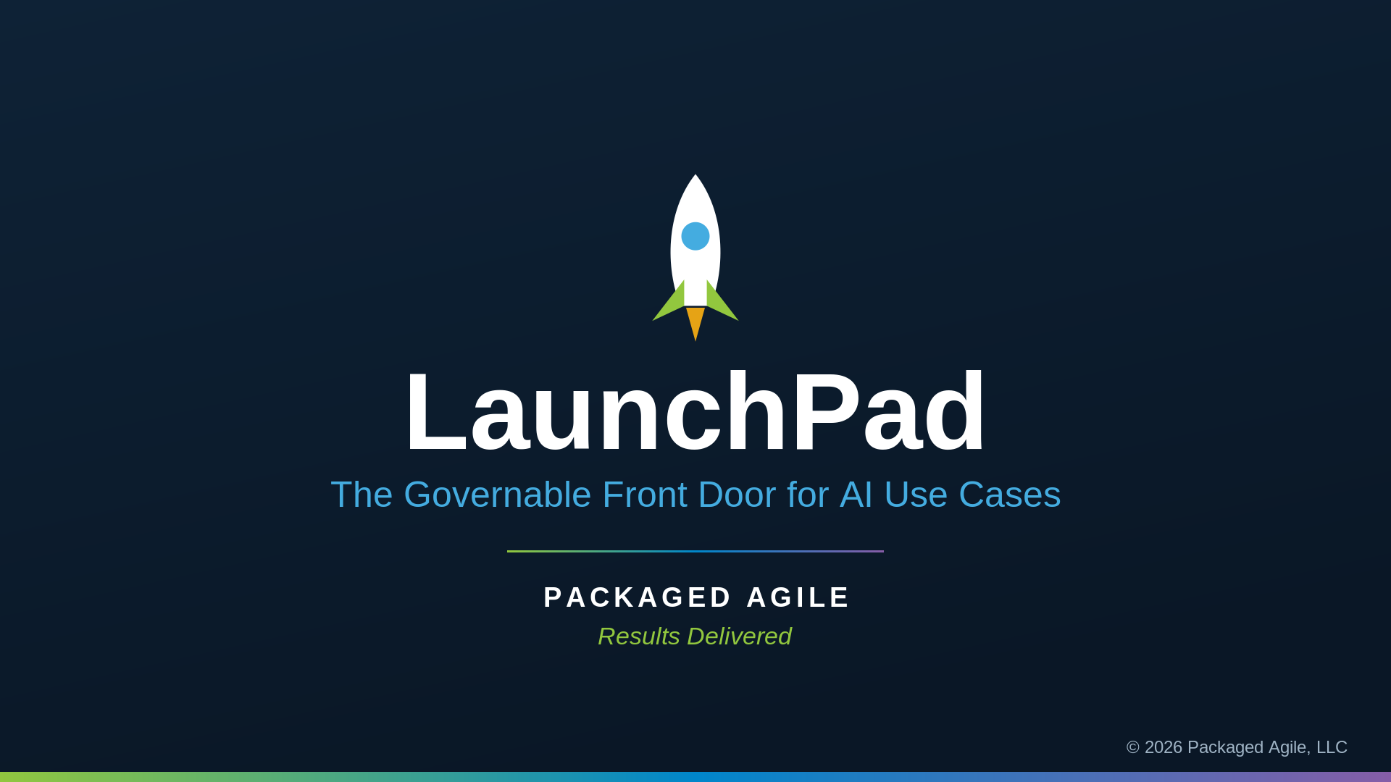
On-screen text: LaunchPad · The Governable Front Door for AI Use Cases · Packaged Agile · Results Delivered
Art direction: Hold ~2.5s. Optional: gentle fade-up on the wordmark and a slight rocket rise. Cut as the first VO line begins.
Voiceover: Across government, AI ideas are everywhere, and almost none of them are governed. I'm Matt Shankle with Packaged Agile. This is LaunchPad.

Frame 2 — 0:12–0:35 — Problem (15%)
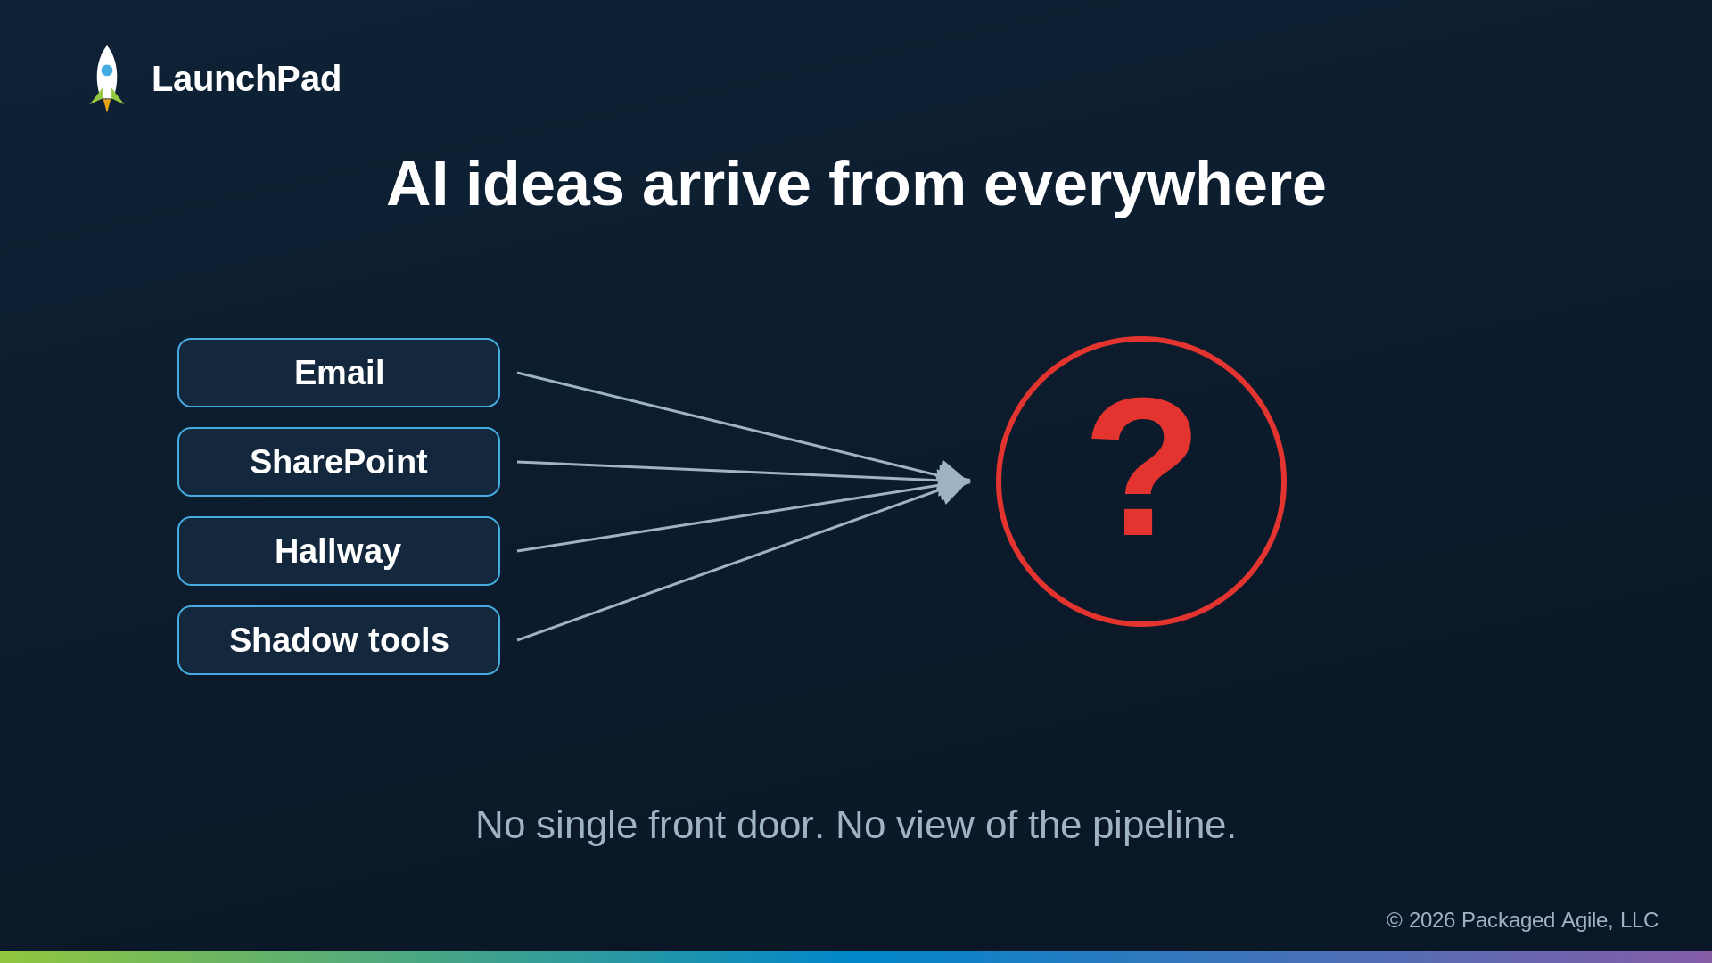
On-screen text: AI ideas arrive from everywhere → ? · No single front door. No view of the pipeline.
Art direction: Animate the four source chips flying in from the left; draw each arrow toward the red question mark. Let the '?' pulse once.
Voiceover: Today, AI ideas reach leadership through email, SharePoint, hallway conversations, and shadow tools. There's no single front door, so no one can see the whole pipeline, compare ideas, or tell which ones are ready to fund.

Frame 3 — 0:35–0:55 — Problem (15%)
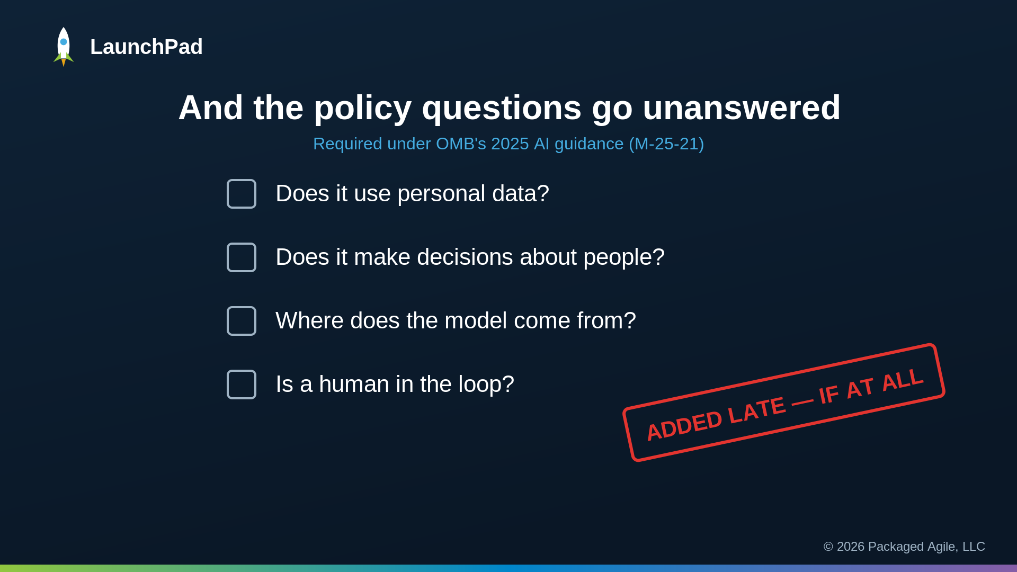
On-screen text: Subtitle 'Required under OMB's 2025 AI guidance (M-25-21)' + four unanswered policy questions + red 'ADDED LATE — IF AT ALL' stamp
Art direction: Reveal each question line in sequence with the empty checkbox. Slam the red stamp onto frame on the line 'added late, if at all.'
Voiceover: Federal agencies are now required to inventory their AI use cases and document the risk of each one. That's OMB's 2025 guidance. Does it use personal data. Does it make decisions about people. Where does the model come from. Is a human in the loop. But the intake feeding that inventory is ad hoc, so those answers get added late, if at all. The result is duplicated effort, stalled experiments, and ungoverned risk.

Frame 4 — 3:28–3:48 — State of the Art (35%)
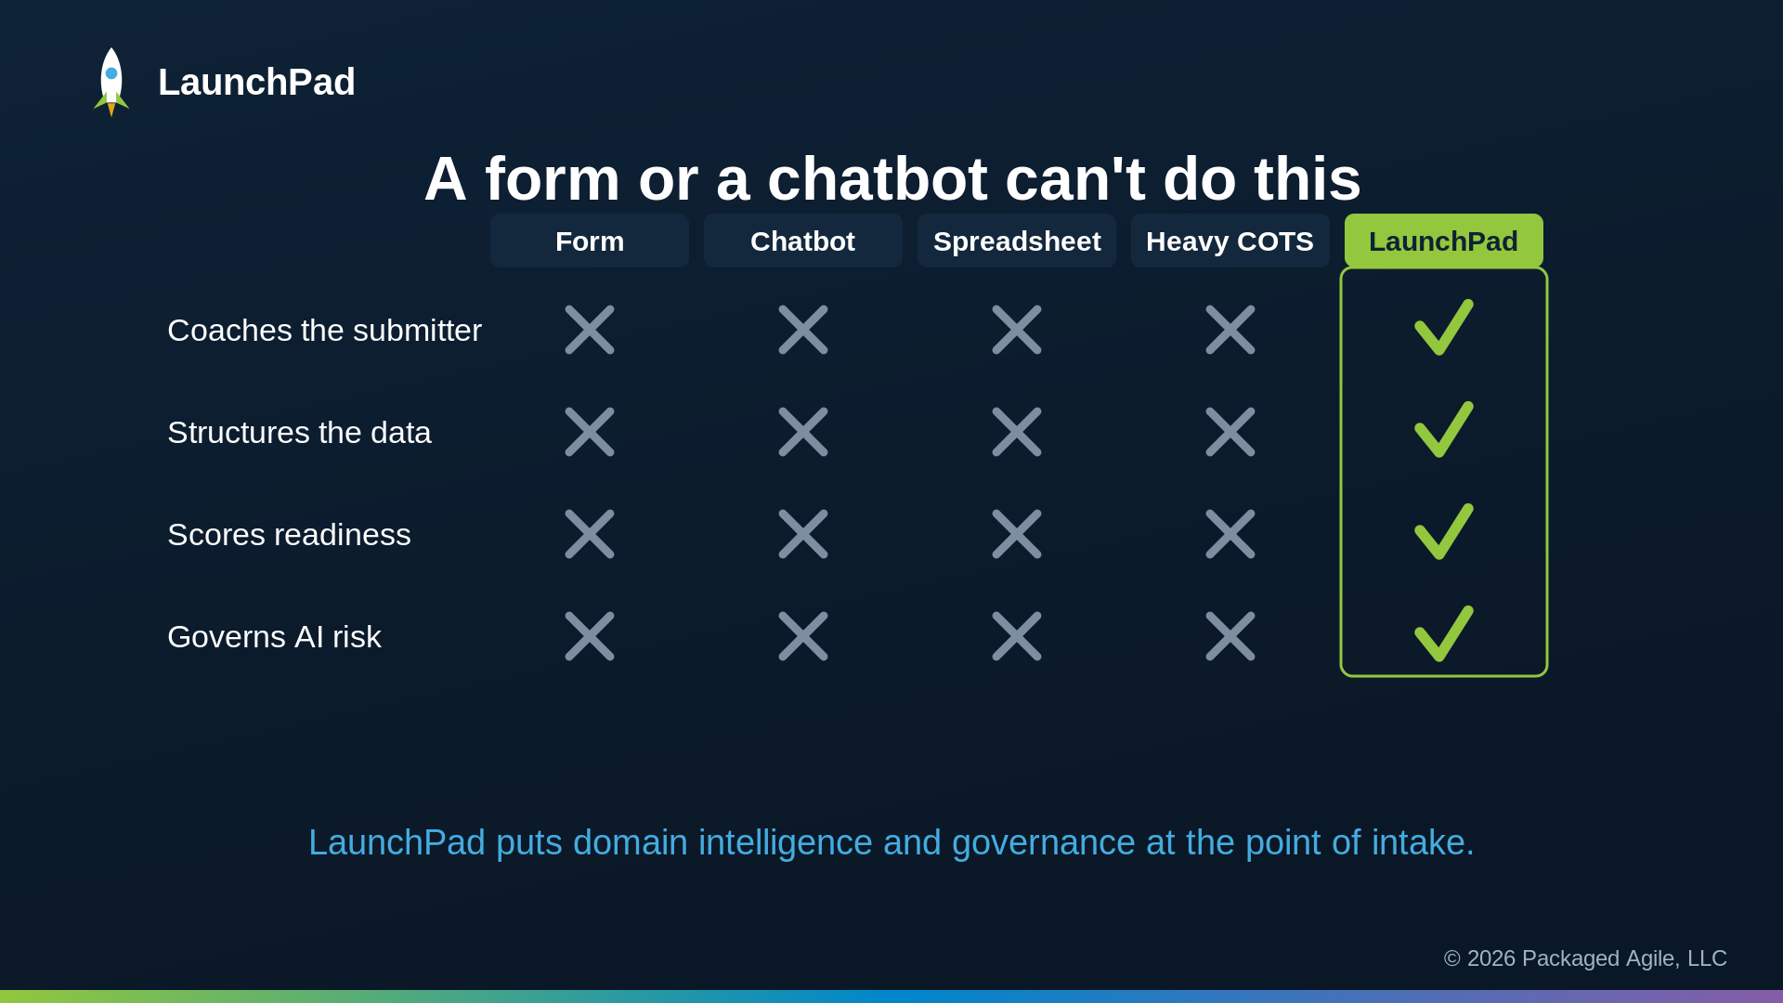
On-screen text: Form / Chatbot / Spreadsheet / Heavy COTS (all ✗) vs LaunchPad (all ✓)
Art direction: Build the column headers left→right. Drop the gray ✗ marks quickly, then pop the four green ✓ in the highlighted LaunchPad column last.
Voiceover: A SharePoint form can collect text, but it cannot coach the submitter, structure the data, or score readiness. A general chatbot leaves no audit trail and no governance. Spreadsheets and email keep leadership blind while shadow AI continues. Heavy enterprise tools were never built to govern AI ideas. LaunchPad puts real domain intelligence at the point of intake and builds the policy guardrails in by design.

Frame 5 — 3:48–4:08 — State of the Art (35%)
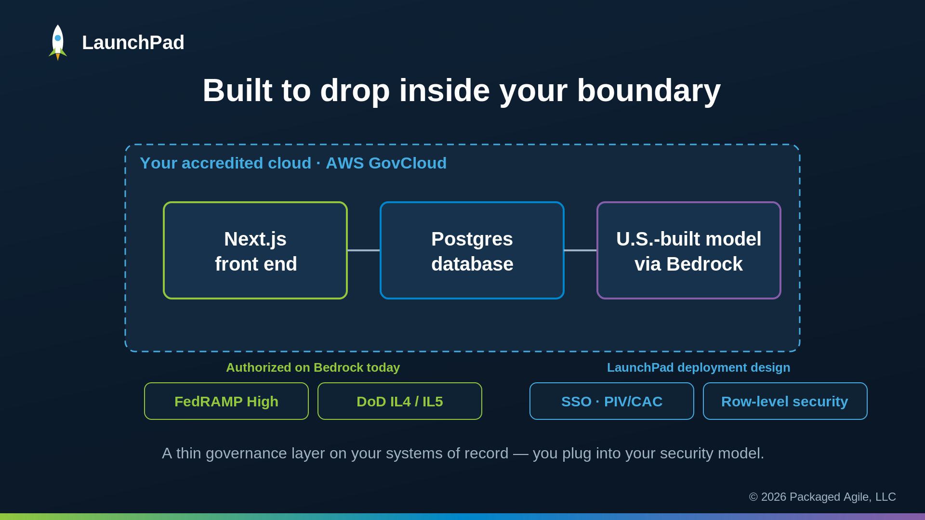
On-screen text: Boundary box (AWS GovCloud) · Next.js → Postgres → U.S.-built model via Bedrock · badges split into 'Authorized on Bedrock today' (FedRAMP High, IL4/5) vs 'LaunchPad deployment design' (SSO·PIV/CAC, RLS)
Art direction: Draw the dashed boundary box first, then the three component boxes with connecting lines. Fade in the badges in TWO labeled groups so the distinction is unmistakable: green = authorized on Bedrock today; blue = LaunchPad's deployment design, not yet accredited.
Voiceover: Under the hood it's a standard web app, Next.js and Postgres, with an American-built commercial AI model served through Amazon Bedrock, where FedRAMP High and DoD Impact Level four and five authorization is already in place in AWS GovCloud. LaunchPad itself is built to deploy inside your accredited boundary, to federate to your identity provider with PIV or CAC, and to enforce row-level security. It's a thin governance layer on your existing systems of record, so you plug into your security model, not ours.

Frame 6 — 4:08–4:20 — State of the Art (35%)
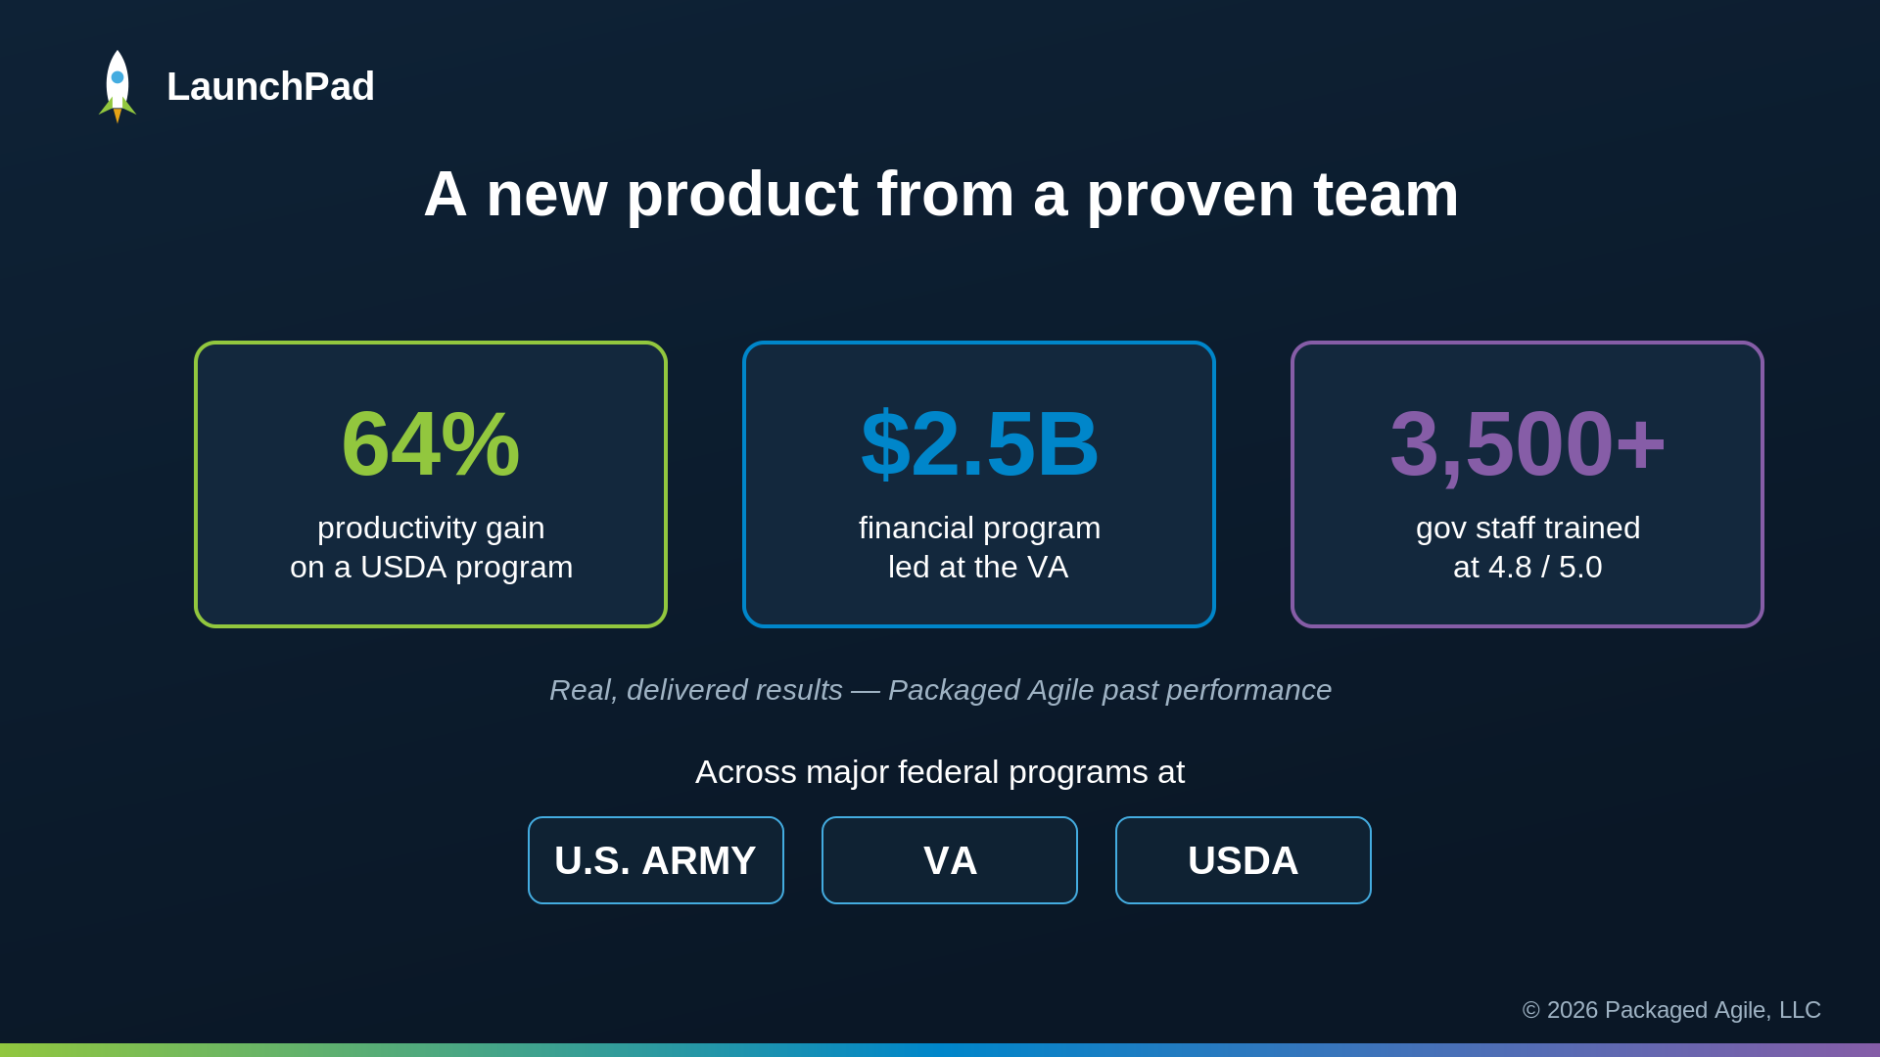
On-screen text: 64% (USDA) · $2.5B (VA) · 3,500+ trained · Army / VA / USDA — real delivered results
Art direction: Count the real numbers up. These are Packaged Agile's delivered past-performance results, not demo metrics — keep them attributed to the company's program record, never to LaunchPad outcomes.
Voiceover: LaunchPad is a new product, but the team and the approach behind it are proven. Packaged Agile has delivered measurable results on major federal programs at the Army, the VA, and USDA, from large-scale agile transformations to training thousands of government staff.

Frame 7 — 4:20–4:42 — Business Model (10%)
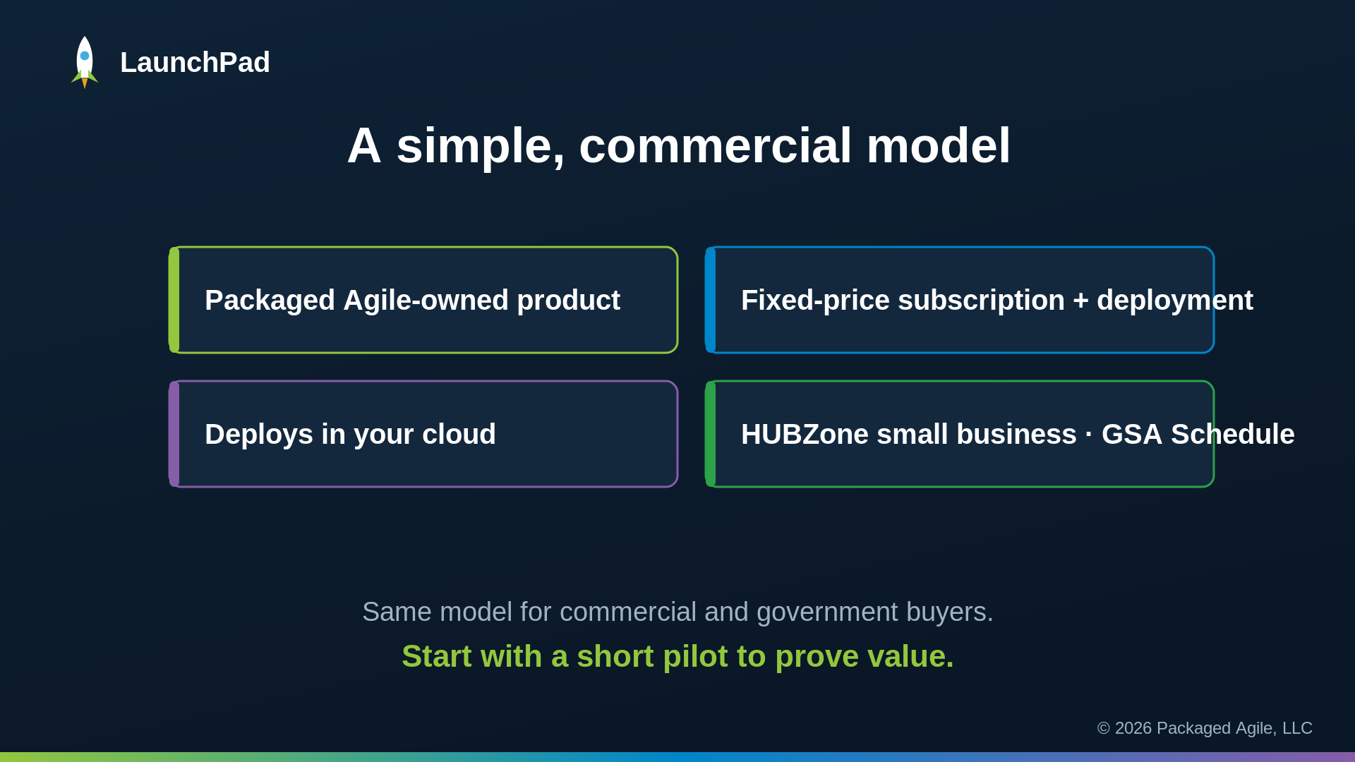
On-screen text: PA-owned product · Fixed-price subscription + deployment · Deploys in your cloud · HUBZone · GSA · Start with a pilot
Art direction: Fade the four cards in one at a time. Emphasize the closing line 'Start with a short pilot to prove value.'
Voiceover: The business model is straightforward. LaunchPad is a commercial software product that Packaged Agile owns. We license it on a fixed-price subscription and deploy it into your cloud with fixed-price configuration and integration, the same model for commercial and government buyers. We are a HUBZone small business and a GSA Schedule holder, so it is directly orderable. And we recommend a short pilot, measured on time-to-decision and how many ideas arrive decision-ready, to prove value before scaling.

Frame 8 — 4:42–4:55 — Close

On-screen text: LaunchPad · Results Delivered · contact line · copyright
Art direction: Mirror the open card. Hold ~3s on the contact line so it can be read and paused.
Voiceover: Stop chasing shadow AI. Give your people one governable front door, and give leadership a clear view of what is worth funding. That is LaunchPad, from Packaged Agile. Results delivered.

Live screen-capture plan — 0:55–3:28 (Accelerating the Mission)
Record LaunchPad at 1920×1080 with a clean browser profile (no bookmarks bar, notifications off). Lower-thirds are optional brand overlays; keep them small and bottom-left, in Packaged Agile blue/green.

Time | Capture this on screen | Lower-third (optional) | Voiceover
0:55–1:08 | LaunchPad landing page; click Start a new idea; wizard opens on the Problem step. | One front door — start an idea | LaunchPad is the governable front door for AI use cases. One intake, where any staff member turns a rough idea into a vetted, decision-ready case. It leads with the problem instead of the solution, so ideas that aren't really AI get caught early.
1:08–1:30 | Type the vague problem; Scout returns ONE clarifying question with clickable options; click one; sharper problem statement folds in. | Scout — server-side, American-built AI. It coaches; the human decides. | Watch what happens when I enter a vague problem. Scout, our AI coach, asks one clarifying question with options I can click. Scout runs server-side on an American-built commercial AI model, configured for your mission and under your control. It coaches me toward a sharper problem statement, but every decision stays with the human.
1:30–1:50 | Solution + Value steps using the seeded sample data; show the value fields being captured (impacted users, cost/time savings, success metrics) — demo values only. | Value, captured at intake | As I move through solution and value, it captures what leadership triages on: impacted users, cost and time savings, and success metrics.
1:50–2:05 | Strategic Alignment opens pre-filled; banner: 'Scout filled this in… please review and edit'; highlighted priorities. | Scout drafts it — you review it | On strategic alignment, Scout has already filled it in from my earlier answers, and it flags that I should review it.
2:05–2:25 | Feasibility / AI-risk questions; PII No, decision No, American-built, human review Yes; risk profile turns green. | Policy disclosures built into intake | Then come the governed parts: the policy-mandated disclosures on personal data, automated decisions, model sourcing, and human review, built into intake rather than added afterward.
2:25–2:40 | Idea Overview: Scout-drafted title/description; readiness verdict 'Ready' + exec summary; click Submit. | Structured, comparable, quality-gated | Every submission comes out structured, comparable, and scored for readiness before a reviewer sees it.
2:40–2:55 | Log in as admin; Pipeline: portfolio by status, color-coded readiness bars; filter by business unit/assignee. | The whole pipeline, at a glance | For leadership, the pipeline shows the whole portfolio by status, color-coded by readiness and routed to the right reviewer.
2:55–3:10 | Open the idea; Scout's reviewer read + risk panel; Request info → Draft with Scout → Send. | Reviewer loop — without losing the thread | Reviewers get Scout's read and a risk panel, and can send a question back to the submitter without losing the thread.
3:10–3:28 | Decision Center; compare 2–3 ideas; open the pre-generated executive briefing. | Decision Center — how leaders decide what to fund | The Decision Center compares ideas side by side and produces an executive briefing with value, alignment, risk, and a recommendation. That is how leaders decide what to fund.

Handoff notes for the editor
- Frames are 1920×1080 PNGs; SVGs are included if you want to restyle or animate them in After Effects / Premiere.
- Keep total runtime under 5:00 (hard cap). Narration is ~4:41; trim dead air in the demo, not the title cards.
- The only permitted on-screen marking is the copyright notice already on the open and close cards. Do not add FOUO/CUI/draft/proprietary marks.
- Export: .mp4, H.264, 1920×1080, under 1.0 GB, Rec709 or sRGB color.
- Brand palette used: green #92c73e, blue #0086ca, purple #865da7 on navy. Display font is a stand-in for Radikal; swap to Radikal if licensed.

